**Object Oriented Programming**

**Laboratory**

**Assignment – 3**

Submitted By:

Yishap Khanal

21052960

CSE-34

Date: 25th August,2022

**Question 1:**

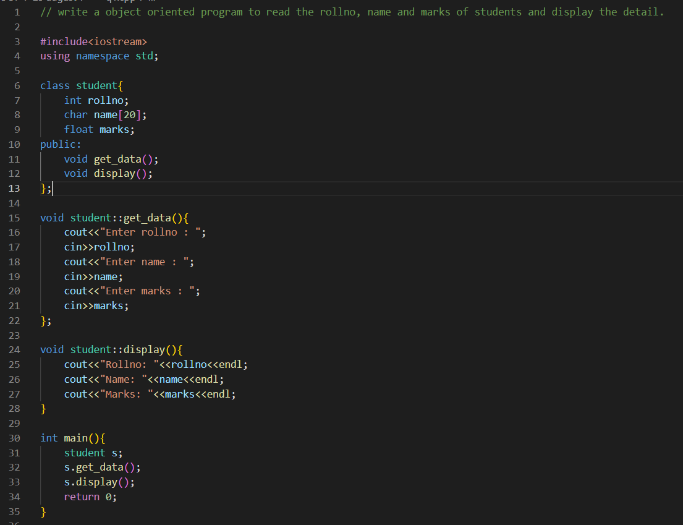

Output:

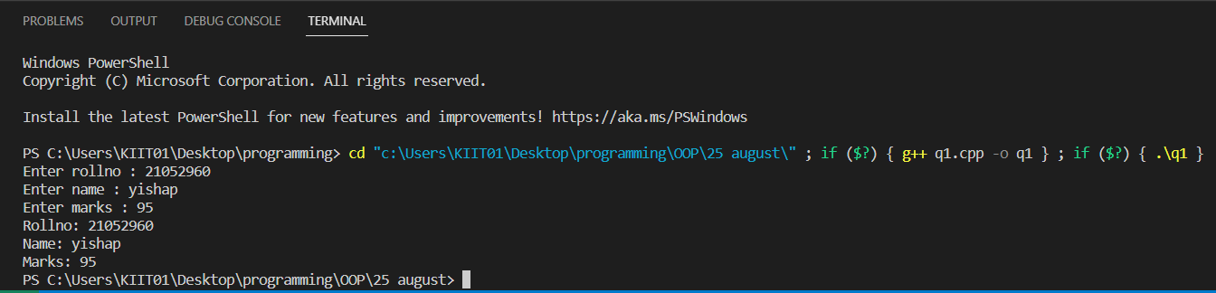

**Question 2:**

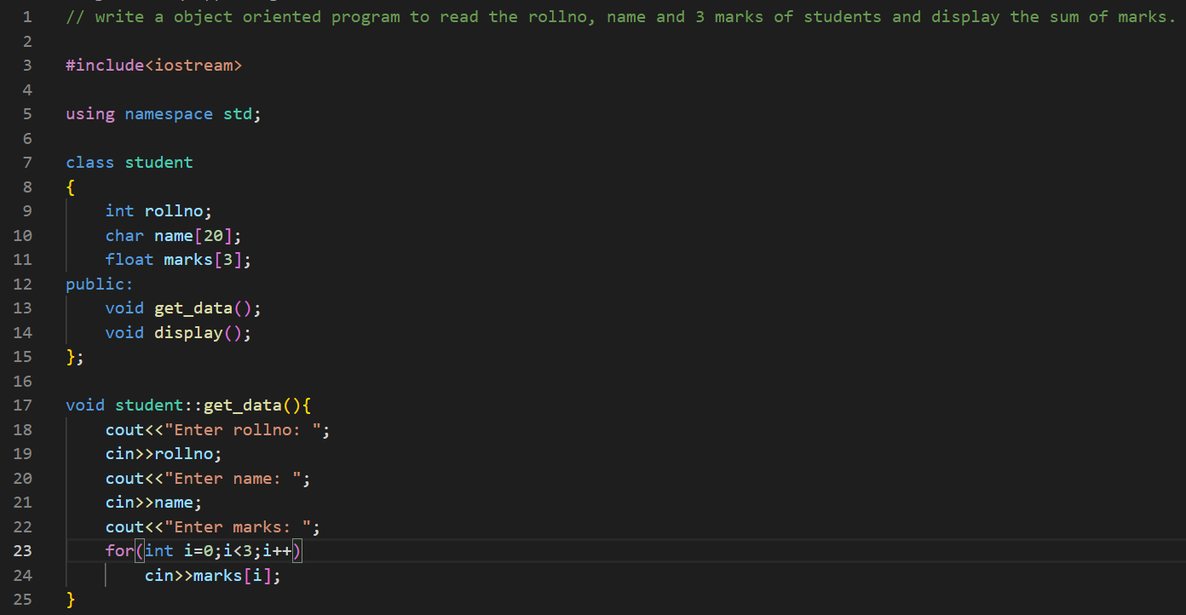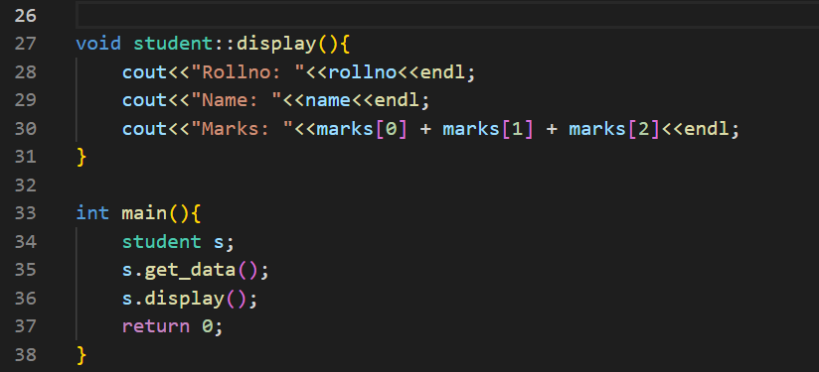

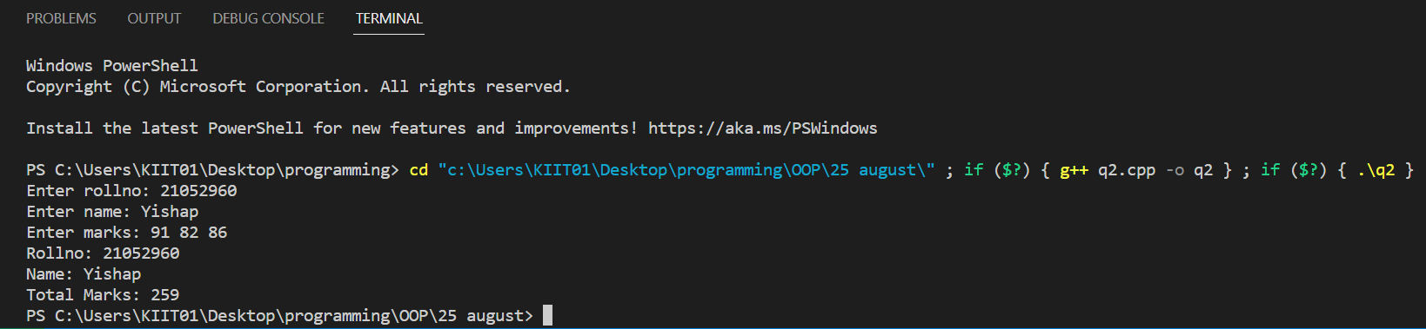Output:

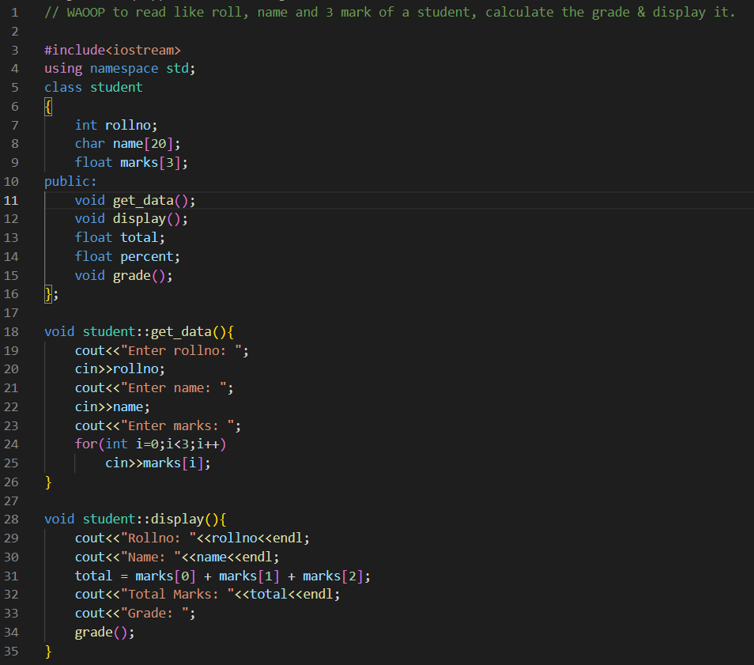**Question 3:**

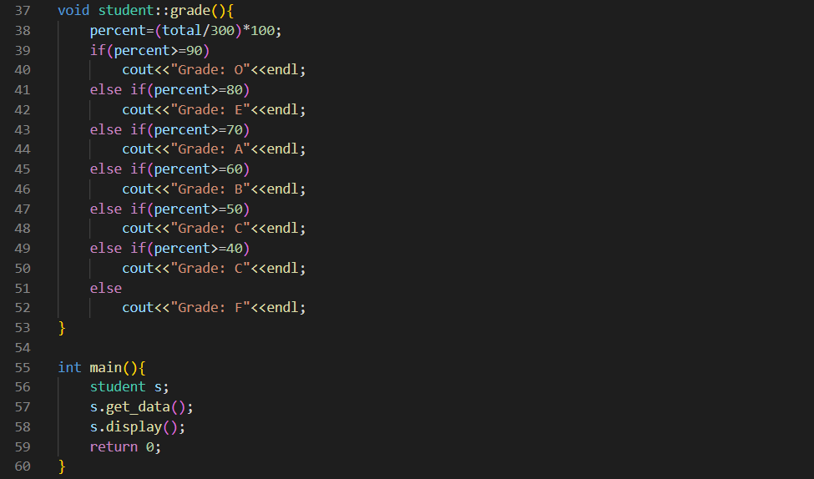

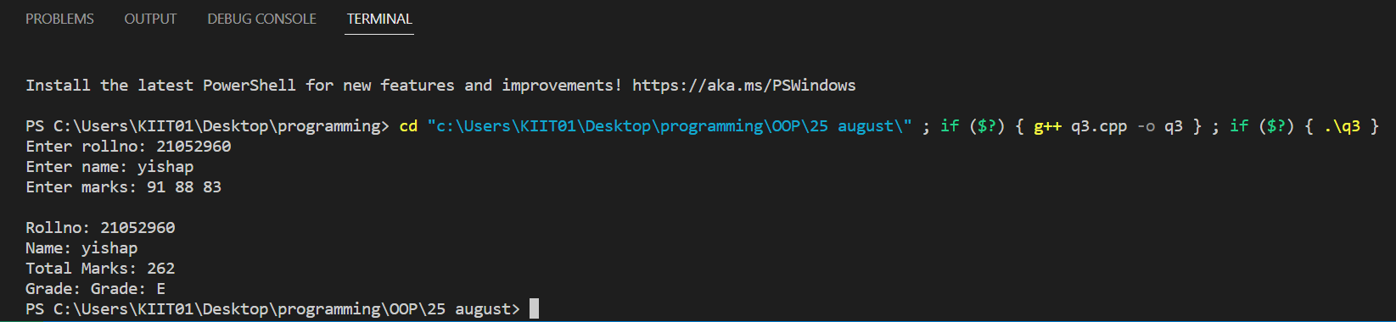Output: